***LOGIN AND GIVE TEST***

***SOFTWARE REQUIREMENT SPECIFICATION***

**Submitted by:**

Miss. Minakshi M. Waghmare

**Supervised by:**

Mrs. Roshan kumar

**TABLE CONTENTS**

* Table of figure

1. Introduction
2. Purpose
3. Scope
4. Definitions ,Acronyms and Abbreviation
5. References
6. Overview

* Overall Description

1. Product Perspective
2. System interface
3. User interface
4. Software interface
5. Hardware interface

* Product Function

1. Context Diagram
2. Use case Diagram
3. Use case Description

* User characteristics

1. User

* Constraint

1. User interface constraint
2. Software constraint
3. Hardware constraint
4. Design standard compliance

* **Specific Requirement**

1. Functional Requirement
2. Use Case scenario1
3. Use Case scenario2
4. Performance Requirement
5. Design Constraint
6. Software system attribute
7. Reliability
8. Availability
9. Portability

**Table of Figure:**

1. Product function
2. Use case diagram
3. User login
4. Menu selection
5. Start quiz

1. **Introduction**
   1. **Purpose:**

The purpose of this document is to capture in natural language and functional level, the description and requirement of project.

Here is short discussion of each requirement.it describes functional and non-functional requirements.

* 1. **Scope:**

The software system will be multiple choice questions like quiz

Where user can get this quiz and can see score.

* 1. **Definition, acronym and abbreviation**
     1. **Login:**

Login is software to help system and user to login with their own data which is already exist .

* + 1. **Quiz:**

Quiz software can access by user to give test.

* + 1. **Reference:**

Probuz and trainer

* + 1. **Overview:**

This is working and as such is subject to change. this information will serve as framework for current definition and future evolution of this project.

1. **Overall description**
   1. **Product perspective:**

Login and give Test is meant to serve as a common platform where registered user can login and give test and check score.it is user friendly user can easily give test.

* 1. **User interface**

This product shall provide a very simple interface to the user so that user can easily login and select otion for give test.

* 1. **Software interface**

Visual studio code where code create in cpp programming logic. this is incomplete description.

* 1. **Hardware interface**

Client side:

Laptop and computers , monitor screen ,keyboards, using this user interact with system.

1. **Product Function**
2. **Context diagram:**

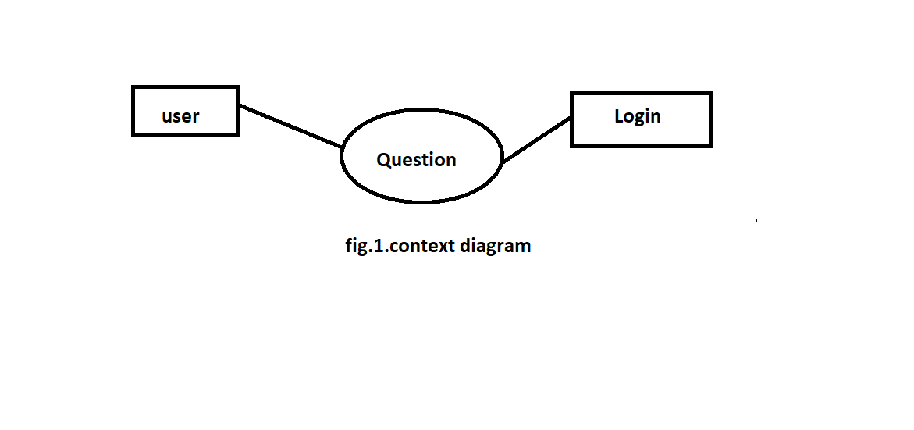**2. Use case diagram:**

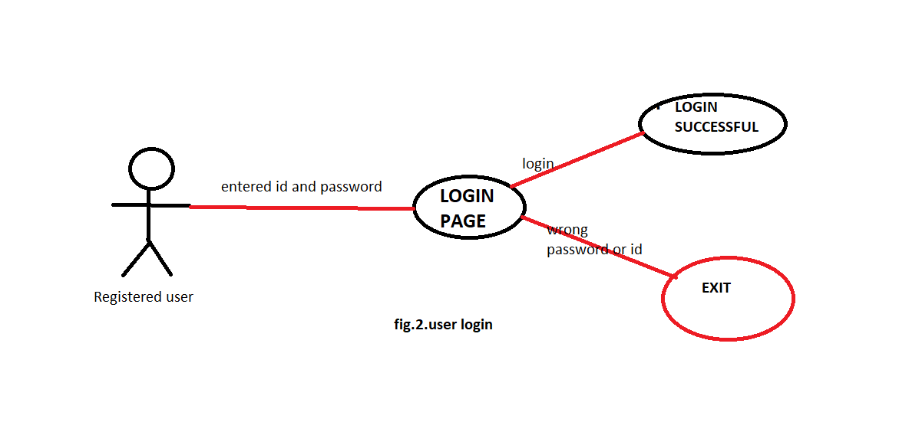

**3. Menu selection**

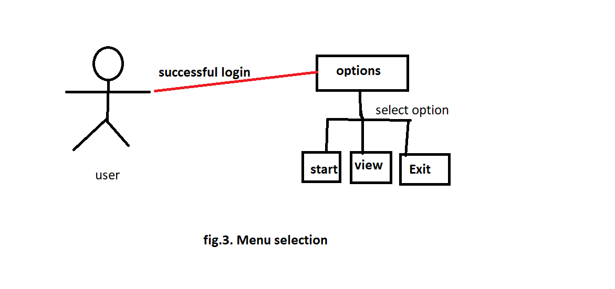

1. **Start test**

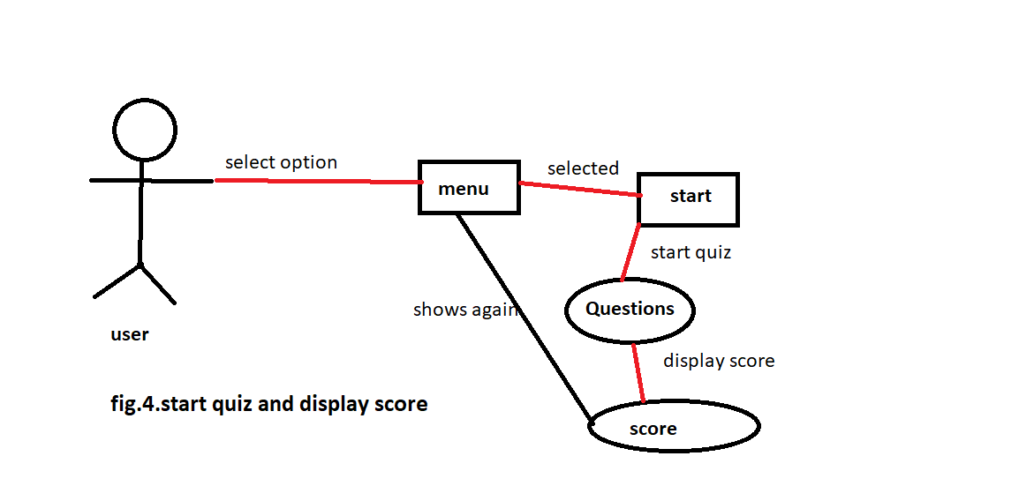

1. **Use case description**
   1. **fig. user login**

Already registered user who has known his login name and password login with his details .if login successful is shows login successful otherwise it shows password is wrong and exit .

* 1. **fig. Menu selection**

After successful login shows next screen of menus where user have to choose any option if he want to give test then select start option ,for view score select view option and for back select exit option.

* 1. **fig. Start quiz /test**

If user select start option on next screen showing questions one by one user have to select right option

If option is right screen shows correct or shows wrong answer with correct option. after completion of questions

On screen shows directly obtained score.

1. **User Characteristics**

**User:**

User is primary user who accessing software for get test.

1. **Constraint**
   1. **User interface constraint**

Using this software is simple and intuitive and

user can familiar with this software very easy.

**7.2. Software constraint**

The software will be run on any IDE or command

Prompt.

**7.3. Hardware constraint**

The system should work on desktop and laptop.

**7.4. Design standard compliance**

This software shall be run on console app in c++

programming language.

**8.Specific requirement**

**8.1 Functional requirement**

***a. use case scenario-user login***

***b. use case scenario-give test***

**a. Use case scenario-user login**

|  |  |
| --- | --- |
| **Purpose** | User logs into software using existing profile. |
| **User** | A user with an existing profile. |
| **Input data** | Profile username and password. |
| **Output data** | Corresponding data. |
| **Pre-condition** | User is not logged into a profile input profile matches with existing data. |
| **Post-condition** | Matched with existing data login successful. |
| **Basic flow** | Matched data with existing data it matches shows logging successful  Otherwise shows wrong password. |

**b.Use case scenario-give test**

|  |  |
| --- | --- |
| **Purpose** | A user wants to start quiz(test). |
| **User** | A legitimate user logged into the software(system). |
| **Input data** | Start quiz. |
| **Output data** | Shows obtained score. |
| **Pre-condition** | User is logged into system shows menu on screen to select menu. |
| **Post-condition** | User wants to start quiz and see score |
| **Basic flow** | The user select menu and start test after complete test on screen directly shows score. |

**8.2. Performance requirement**

The system support one at time who already registered

With his details.

**8.3. Design constraint**

The software(system)/product will be written in c++

Programming language output must compatible with

console app.

**8.4 Software system attributes**

1.Visual studio code

2.RAM(memory).

**8.5 Reliability**

The reliability of the overall program depend on the

Separate components.

**8.6 Availability**

The system code should available in laptop or computers

for perform or run code.

**8.7 Portability**

This software run on other IDE also.